Full test June 2023

Start, loading, output saving

- Start App by command line -> OK

- Try clicking 'Draw Plot', 'Save as PDF' and 'save settings' without having loaded a template -> give a warning -> OK

- Load a template from the Z4 paper (figure 1 - CTRL / ARS2 RNA/TT-seq) and export it right away to get the latest version of the excel sheet -> OK

- loading a bed file instead of excel -> OK gives warning

- load a random excel -> gives warning of missing sample sheet -> OK

- load most minimal excel (folder, track names, structure) -> loads and plots based on coordinates -> OK

- load same excel without folder -> OK gives warning

- same with only one foldr path for 2 datasets -> plots OK just with empty tracks for files from other folder, with warning

- same without stricture -> gives warning

-same with only a dataset name -> OK asks for a subgroup

- same with one subgroup -> plots ok and gives warning for 'missing tracks

- same without strands -> ok gives warning

- Try loading the excel template and plotting GAPDH -> OK
- Reset session and try loading excel sheet after unticking 'load annotation during import' and plotting GAPDH -> OK (upon few back and forth trials, behavior is as expected in term of relative time of loading session and plotting speed depending on the option being ticked or not).

- Reset session and plotting GAPDH, then saving -> OK

Locus / Coordinates

- Reset session and reloading excel, then plotting based on coordinates -> OK
- Similar try while forgetting to specify strand -> OK plots, + strand by default
- Similar while using a dash instead of : between start and stop coordinates
- Similar while removing 'chr' from the chromosome name -> makes an empty plot (equivalent to dummy)
- Similar while adding GAPH locus name -> OK plots GAPDH -> locus overrules coordinates as expected
- Similar with GPADH (typo) -> OK, gives warning
- Similar with gapdh (low case) -> OK, gives warning
- Similar with NA or empty space -> OK, gives warning
- Entering NA as coordinates -> Gives error 'missing value where TRUE/FALSE needed' but app does not crash and gives warning 'plotting failed please check your settings'
- Same with NULL
- enter coordinates of negative length, gives warning and plot 100bp

- Plotting GPADH with the different verbosities -> OK (no warning was tested by placing the bin to minimum, which in normal verbosity says it sets it back to default)

Tracks selection and colors

- test of track selection for individual track or dataset -> OK

- test of tracks color definition alone or with selection of a subset of tracks to display -> OK

- Export of excel sheet -> colors exported as intended

Plot layout

- Scaling factor -> OK

- Dummy plot ->

- Exclude title -> OK

- Title -> OK with text, number, NA, NULL, delta (as a special character)
'Title' with 'exclude title' -> OK

- Display genomic scale -> OK

- Display genomic scale above tracks -> OK
- together with display genomic scale -> OK

- Tracks opacity -> OK with or without display of both strands

- Intermingled display -> OK with all versions of color and still taking into account opacities variations previously set

- Reverse strand as negative value -> OK and no problem if intermingled display is also ticked.

- Plot AC006064.3 (next to gapdh but reverse) with plot 5' left to 3' right but with both strands display -> OK (still plot with regular orientation)
- Same after removing display both strands -> OK works as expected whether strands are represented as positive or negative values

- Reset session and reloading, then plot GAPDH in detailed verbosity to get the panels orders
upper: header,scale,RNA-seq,line-spacer,TT-seq,empty-spacer,annotations
in Display both strands
.) upper: header,scale,RNA-seq,line-spacer,TT-seq,empty-spacer,annotations
.) lower: thickline-spacer,annotations,empty-spacer,RNA-seq,line-spacer,TT-seq
Return verbosity to normal and start using ploting segment orders

- With 'display both strands' activated
x 'annotation,RNA-seq,TT-seq' (missing an 's' at annotations) -> OK gives warning of unexpected fragment
x 'annotations,RNA-seq,TT-seq' -> OK plots wanted segments only in the order specified for both plus and minus strand
x id but adding only 'header' in minus -> OK gives warning that header should be on the plus side
x id in plus, but gives only 'scale' in minus -> OK gives a warning that annotations needs to be specified in both plus and minus
x id in plus, but giving only 'scale,annotations' in minus (so no seq data) -> OK gives an error 'argument of length 0', but the app does not crash and gives a warning 'plotting failed please check your settings'
x give ' annotations,RNA-seq,TT-seq' in plus (same as before) and ' scale,annotations,RNA-seq' in minus -> OK gives an error 'argument of length 0', but the app does not crash and gives a warning 'plotting failed please check your settings'
(same as before, most likely because not every RNAseq to plot are listed)
x id but give ' scale,annotations,RNA-seq,TT-seq' in minus -> OK, plots as expected
x removal of TT-seq from plus strand -> same error as before
x same if TTseq is also removed from minus strad (so problem is the missing dataset and not the difference between plus and minus
x list back TTseq from both plus and minus strand, but untick it from the list of samples to plot -> OK, gives error 'names attribute [1] must be the same length as the vector [0]' , but the app does not crash and gives a warning 'plotting failed please check your settings'
x retick to plot TTseq -> plots OK
x untick to plot both strands while the plotting segment order for minus strand is still listed -> OK plots
x plotting segment order with NA or 0 -> OK gives warning and list fragments to use
x plotting segment order with NULL -> OK, does not plot and give warning (although structure of warning seems unusal)
WARNING(s):
- "Plotting Segment Order" argument is NULL - automatically setting to
ERROR(s):
- "plotting_segment_order" argument is NULL - aborting
NULL

Reset session and reload excel

Plot Display parameters

- up/downstream extension -> OK

- tracks heigh -> OK
- untick -> ok gives wraning that full plot height need to be activated
- activate full plot height -> OK
- retick track heigh -> OK (overruled by full plot height)
- Deactivate full plot height -> ok track height considered again

- title field height -> OK larger when requested; ignored if made too small to the chosen case for title (add this info to the tool tip?)
- Untick with or without plot full height -> OK

- genomic scale height -> OK (large or small, the typo case adjust)
- unticked -> OK
- with full plot heigh ticked -> OK (makes all the typos big to fill the space)
- Untick full plot height

- Annotation height -> large OK
At this point while trying to test the small, plotting failed and an error was given 'too many open devices', most likely as there were too many windows of plot opened (I believe 63) -> due to sheer number or memory consumption? (like do big ones take more memory than small ones?)
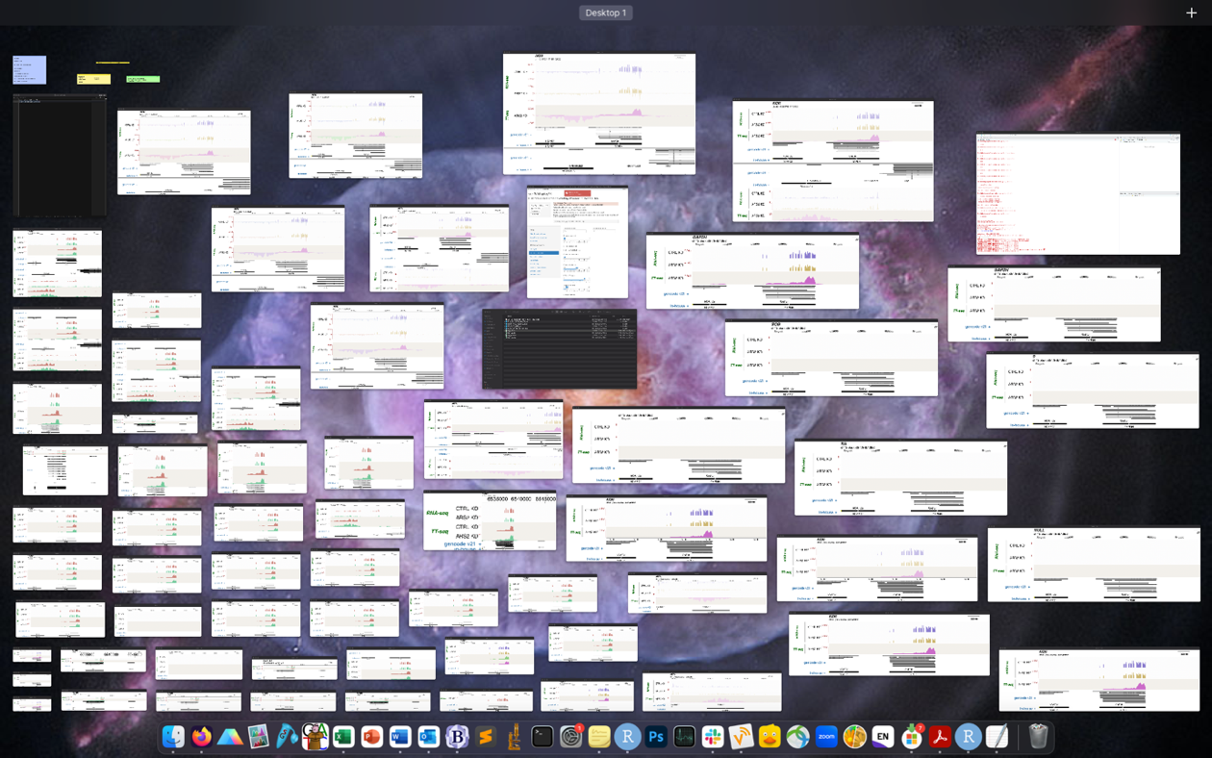
All windows were closed without resetting the app and plot was retried -> works
- Annotation size small -> OK
- untick -> OK
- tick full plot height -> plots OK but size issue: the full plot heigh is set to 10 but in detailed verbose it gives 38
Detailed Output:
- "Plot Dimensions (w scaling)":
.) Plot Width: 39.346 cm
.) Plot Height: 38.554 cm
- "Plot Dimensions (w/o scaling)":
.) Plot Width: 32.788 cm
.) Plot Height: 32.128 cm
- "Width of panels (w/o scaling)":
.) All panels: 32.788 cm
.) Left (sample names): 16.988 cm
.) Scale: 0.7 cm
.) Margins: 0.05 cm
.) Tracks: 15 cm
- "Height of panels (w/o scaling)":
.) All panels: 32.128 cm
.) Header: 0.66 cm/segment
.) Genomic scale: 1.844 cm/segment
.) Tracks: 2.305 cm/segment
.) Line-spacer: 0.06 cm/segment
.) Empty-spacer: 0.06 cm/segment
.) Thickline-spacer: 0.12 cm/segment
.) Annotation: 1.844 cm/line
.) Squished annotation: 0.922 cm/line
.) Annotation text: 1.844 cm/line
- "Panel text orientation":
.) RNA-seq: HOR HOR
.) TT-seq: HOR HOR
- "Panel font sizes":
.) RNA-seq: 46 46
.) TT-seq: 46 46
- "Other font sizes":
.) Title: 9
.) Subtitle: 6
.) Scalebar: 6
.) Genomic scale: 38
.) Data scale: 6
.) Dataset names: 46
.) Sample names (max): 46
.) Sample names (min): 46
.) Annotation titles: 46
.) Annotation names: 46
- "Plotting Segment Order":
.) upper: header,scale,RNA-seq,line-spacer,TT-seq,empty-spacer,annotations

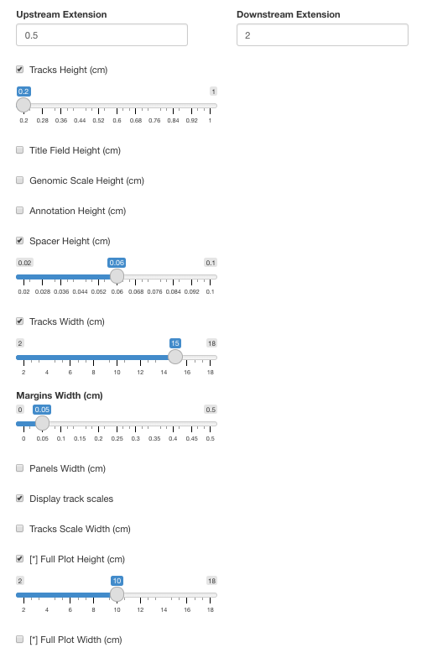

- Reseting app, reloading and the unticking only 'annotation height' and ticking 'full plot height' for 10cm
WARNING: "Tracks Height" = 1 and "Full Plot Height" = 10
.) one of the arguments should be a positive numeric value and the other should be NULL
.) "Tracks Height" set to NULL
ERROR(s):
- Feature Names Font Size = 45:
.) Feature Names Font Size[1] = 45; it should preferably be between 4 and 12
ERROR(s):
- Annotation Title Font Size = 45:
.) Annotation Title Font Size[1] = 45; it should preferably be between 4 and 12
automatically setting bin size to 3
loading RNA-seq & TT-seq tracks from + strand(s)
ERROR(s):
- Calculated Height in Inches = 11.00787996:
.) Calculated Height in Inches[1] = 11.00787996; it should preferably be between 0.5 and 10.51182
ERROR(s):
- Calculated Width in Inches = 12.76378642:
.) Calculated Width in Inches[1] = 12.76378642; it should preferably be between 2 and 10.51182
plotting GAPDH@chr12:6529479-6542822
plotting RNA-seq data for samples
CTRL KD ARS2 KD
plotting TT-seq data for samples
CTRL KD ARS2 KD
plotting gencode v21+ annotation
plotting in-house+ annotation

Detailed Output:
- "Plot Dimensions (w scaling)":
.) Plot Width: 38.904 cm
.) Plot Height: 33.552 cm
- "Plot Dimensions (w/o scaling)":
.) Plot Width: 32.42 cm
.) Plot Height: 27.96 cm
- "Width of panels (w/o scaling)":
.) All panels: 32.42 cm
.) Left (sample names): 16.62 cm
.) Scale: 0.7 cm
.) Margins: 0.05 cm
.) Tracks: 15 cm
- "Height of panels (w/o scaling)":
.) All panels: 27.96 cm
.) Header: 0.66 cm/segment
.) Genomic scale: 0.24 cm/segment
.) Tracks: 2.245 cm/segment
.) Line-spacer: 0.06 cm/segment
.) Empty-spacer: 0.06 cm/segment
.) Thickline-spacer: 0.12 cm/segment
.) Annotation: 1.796 cm/line
.) Squished annotation: 0.898 cm/line
.) Annotation text: 1.796 cm/line
- "Panel text orientation":
.) RNA-seq: HOR HOR
.) TT-seq: HOR HOR
- "Panel font sizes":
.) RNA-seq: 45 45
.) TT-seq: 45 45
- "Other font sizes":
.) Title: 9
.) Subtitle: 6
.) Scalebar: 6
.) Genomic scale: 5
.) Data scale: 6
.) Dataset names: 45
.) Sample names (max): 45
.) Sample names (min): 45
.) Annotation titles: 45
.) Annotation names: 45
- "Plotting Segment Order":
.) upper: header,scale,RNA-seq,line-spacer,TT-seq,empty-spacer,annotations
total plotting time: 17.28329 secs
plot done
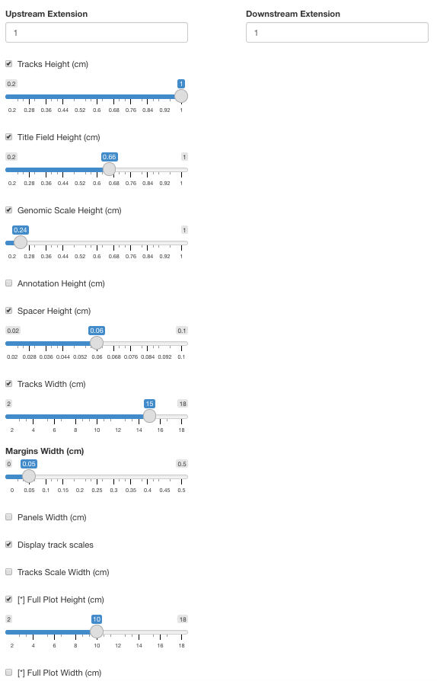

resetting and reloading

- Spacer height -> OK
- untick -> OK
- tick full height -> OK
- retick spacer height and untick full plot

- Track width -> OK
- untick -> OK gives warning that full width needs to be ticked
- tick full plot width -> OK gives a warning that panel width needs to be specified
- tick panel width -> OK gives a warning that track scale width also need to be set
- tick track scale width -> OK plots
- changing up and down of 'margin width' / panels 'width' / 'track scale width' / 'full plot width' -> all values work and plot, sometime with some overlapping of text in the genomic scale due to small size but this is up to users
- when using the following parameters plot returned a warning that the overall size would be too small to display tracks
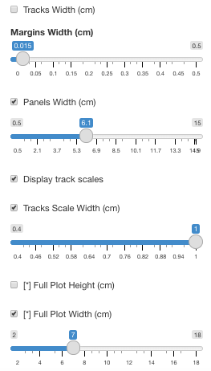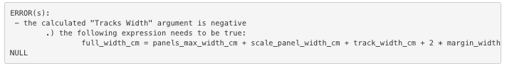

- Unticking of full plot width and reticking of tracks width and various adjustment of 'margin width' / panels 'width' / 'track scale width' / 'tracks widths' -> OK all plot
Potentially add a warning when 'track scale width' is too small as numbers might get truncated or some of the first digits disappear.

Reset session

Datasets specific options
(specifying arguments for datasets not plotted works)

- mease of replicate -> OK

- negative value minus strand tried on one of the present dataset which are not minus (on display both strand and minus strand represented as positive values) -> the chosen dataset is presented as an empty track, suggesting that the positive values (expected to be negative) were minus transformed and therefore not displayed on the positive side -> OK

- binning value max -> OK
- binning value median -> OK
from left to right mean, max, median (for minus strand of GAPDH plot)
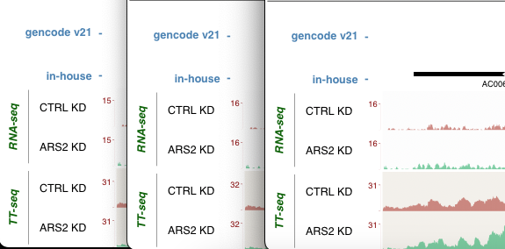

- enhance signal -> OK

- log transform -> OK

- pseudo count -> OK
- pseudo count of 0 -> OK gives a warning and correct to 1

- set negative values to 0 -> not tested and no dataset comes to mind for test

- batch correction -> batches specified for RNAseq and deactivated in plotting -> OK plots and scale is slightly different

Panels display

- full panel width (without setting panel width) -> OK
- with panel width -> OK
untick both

- panel text orientation -> OK both for first panel and inner panel

- one line samples names -> OK

- relicate prefix -> NULL OK / NA returns error 'missing value where TRUE/FALSE needed' NUT, the tooltip describe that NA is actually what should be given to get only a number (a white space does the trick though) / works for text number spaces and special characters

- colors first and inner anels ok

- panels text font size first and inner ok

- detailed font ok

- display leftmost panel OK

- spacers ok

- horizontal and vertical spaces alone or in combination with 'spaces' OK

- colors of 3 categories of spacers OK

- alternating backgrounds ok

- definition of their colors ok

- opacity ok

Tracks binning

- bin size to 1, 10, 1000 -> OK

- bin center -> with value outside of plotted area -> gives warning, sets to default and plot -> OK
-> with value in the plotted area but not the plotted TU (plotting made based on GAPDH locus) -> states that position is outside of plotting area, sets to default and plot
-> with a value within GAPDH -> gives error 'object '.bin.start' not found' and fails to plot
-> same error if trying to plot based on coordinates (whether specified bin is within GAPDH or within the plotted area but outside GAPDH)

- bin per cm -> OK

Header and Genomic Region

- header font sizes -> the 3 works ok

- header colors -> the three works ok

- genomic scale font size -> OK

- genomic scale color -> OK

Data scales display

- group auto scale -> OK

- manual scaling -> OK -> overrules autoscale whether it is enabled or not, works independent for both strands displays the line showing 'truncated' data plotting

- scientific notation -> ok for all settings

- data scale font size -> OK

- data scale color -> ok

Annotation display

- packing generally works but issue specific to the inhouse annotation: both in expanded and squished, it has a background line covering the whole field
(issue could originate from by BED)
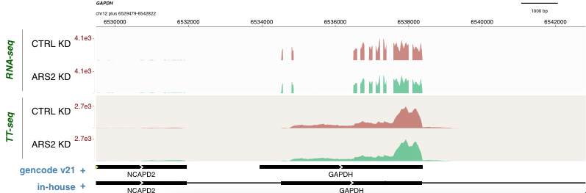

- display features names -> OK

- name according to density -> OK

- name above -> OK

- reverse strand features names opposite -> OK with or without both strands

- brackets -> OK

- colors -> OK

- font sizes -> OK with or without names display

- font color -> OK

- annot names font size -> OK

- annot names colors -> OK

- loci shading -> OK

- shading colors -> OK

- shading oppacity -> OK

Browser based plotting

Firefox

plots OK
saves OK
Export sessions OK

Safari

plots OK
saves OK
Export sessions OK

Google Chrome

plots OK
saves OK
Export sessions OK

